**DAILY ONLINE ACTIVITIES SUMMARY**

|  |  |  |  |  |  |  |  |  |
| --- | --- | --- | --- | --- | --- | --- | --- | --- |
| **Date:** | **30-05-2020** | | | | | **Name:** | **Dhanush Shetty** | |
| **Sem & Sec** | **8 A** | | | | | **USN:** | **4AL16CS032** | |
| **Online Test Summary** | | | | | | | | |
| **Subject** | | **-** | | | | | | |
| **Max. Marks** | | **-** | | **Score** | | | **-** | |
| **Certification Course Summary** | | | | | | | | |
| **Course** | **Understanding CIDR Notation.** | | | | | | | |
| **Certificate Provider** | | | **AWS** | | **Duration** | | | **5 mins** |
| **Coding Challenges** | | | | | | | | |
| **Problem Statement:**   1. **Write a C Program find the number that is missing from the array containing n distinct number taken from 0,1,2....n.** | | | | | | | | |
| **Status: Solved** | | | | | | | | |
| **Uploaded the report in Github** | | | | | **Yes** | | | |
| **If yes Repository name** | | | | | **Dhanushshett/online_c_coding_repository** | | | |
| **Uploaded the report in slack** | | | | | **Yes** | | | |

Online Test Details: (Attach the snapshot and briefly write the report for the same)

NOT CONDUCTED

Certification Course Details: (Attach the snapshot and briefly write the report for the same)

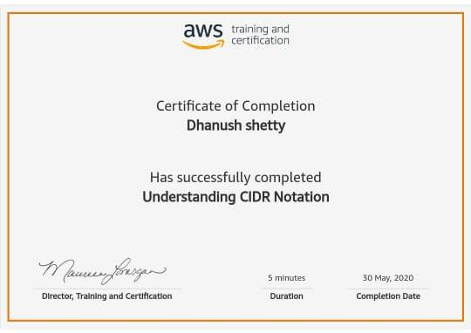

Coding Challenges Details: (Attach the snapshot and briefly write the report for the same)

**PROGRAM 1 .**

**//Write a C Program find the number that is missing from the array containing n distinct number taken from 0,1,2....n.**

**#include <stdio.h>**

**int getMissingNo(int a[], int n)**

**{**

**int i, total;**

**total = (n + 1) * (n + 2) / 2;**

**for (i = 0; i < n; i++)**

**total -= a[i];**

**return total;**

**}**

**int main()**

**{**

**int a[] = { 1, 2, 4, 5, 6 };**

**int miss = getMissingNo(a, 5);**

**printf("%d", miss);**

**getchar();**

**}**